Preface

Hello my name is David Baldwin. And I would like to thank you for using this VI Tutorial packet. This packet is my very first VI tutorial packet. That said, my primary goal for this packet is to provide the basic functionalities or topics of the VI editor. A special thanks goes to Sharon Jenice Johnson and Cornelia Chislom, who did their best to address any erroneous grammatical and technical writing found in the alpha version VI Tutorial packet. The primary audience groups for the packet are high school and college level programmers. The packet will go through three stages of production: alpha, beta, and omega. During the alpha stage I will request that you as the reader make notes in the packet to point out new ideas, unmentioned topics, erroneous terminologies, and difficult or vague concepts. I do not want this tutorial packet to be anymore difficult to read and comprehend than a ninth grade reading book. At the beta stage, I will take all the notes given in the alpha stage and address those issues in the beta stage. It is my hope to the beta stage will be made available to the general public with the hopes that negative and positive feedback will be given on the packet. When enough feedback has been given, I will make a final packet for publication. That is the game plan. That said, since the packet is at the alpha stage please make lots of notes. My policy is there is no such thing as an overcritical statement. Regarding copyright, I would request that you consider following the fair-use principle to copy-righting. Seeing as how you may easily find a comprehensive free tutorial online, I request that while the packet is in the development stages (alpha and beta) stage please be supportive and understanding regarding the packets selling price. I have gone through great lengths to make the packet as affordable as possible. I strongly believe in a free knowledge therefore, I will not seek to renew the packets copyrights.
Thank you,
David Kortney Baldwin
UT Knoxville Computer Science
Table of Content

- VI Command, Insert, and Toggle modes
- Basic Movements (Up, Down, Left, Right)
- Advanced Movements
- Jumping to beginning, middle, and end of a file
- Advanced Jumping techniques
- Deleting from a file

VI Tutorial Packet Alpha ver.
Written by David Kortney Baldwin
Editors: Sharon Jenice Johnson & Cornelia Nicole Chislom
Illustrations by David Kortney Baldwin
WHAT IS VI?
VI is a visual editing tool. The name derives from the word “Visual”. William Joy wrote the original VI program. VI is the standard visual editor for all UNIX operating systems. VI can be considered to be the arch rival to the Emac visual editor. VI has many features that are helpful for programmers. The purpose of this tutorial is to help you learn how to utilize all, if not most, of the VI features.

How to obtain VI!
If you are using VI on a windows computer this is a very important section for you. There are only a two ways to obtain a VI editor on a non-linux based computer. The easiest way to obtain VI is to SSH into a computer running a Linux operating system. The other method requires that you install a Linux operating system onto the computer of choice. This tutorial packet will assume that you have access to VI in one of these two ways already. However, I will show how to SSH into a server. Being able to remotely log into a server is a very easy, yet powerful ability. This means that you will not need to be in front of a Linux computer or even get out of bed, in order to use VI. First download an SSH tool, my favorite is PUTTY. So I will show you how to download and use putty.

GOOGLE and Download “PUTTY”
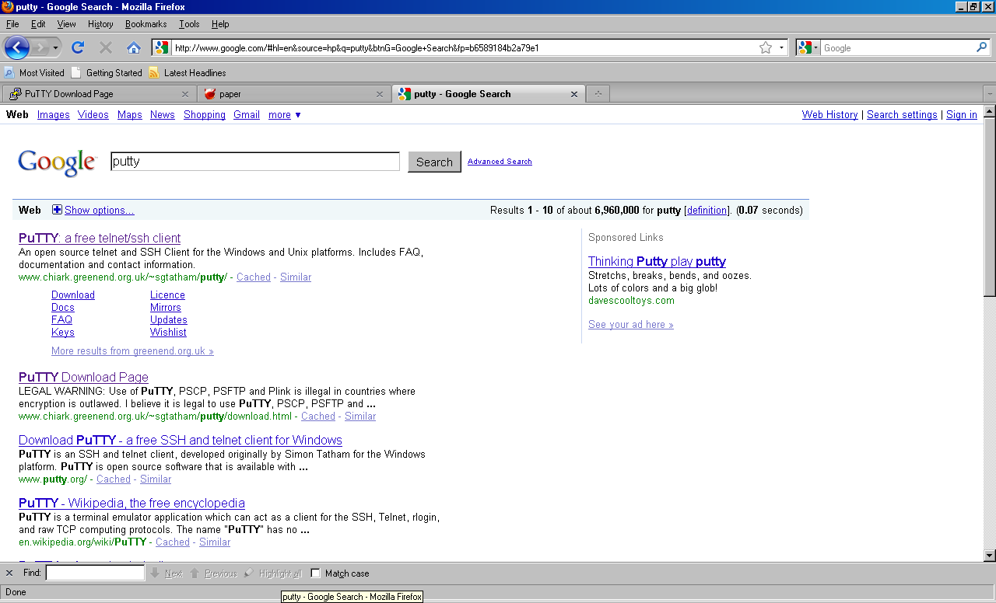

Select “Download”
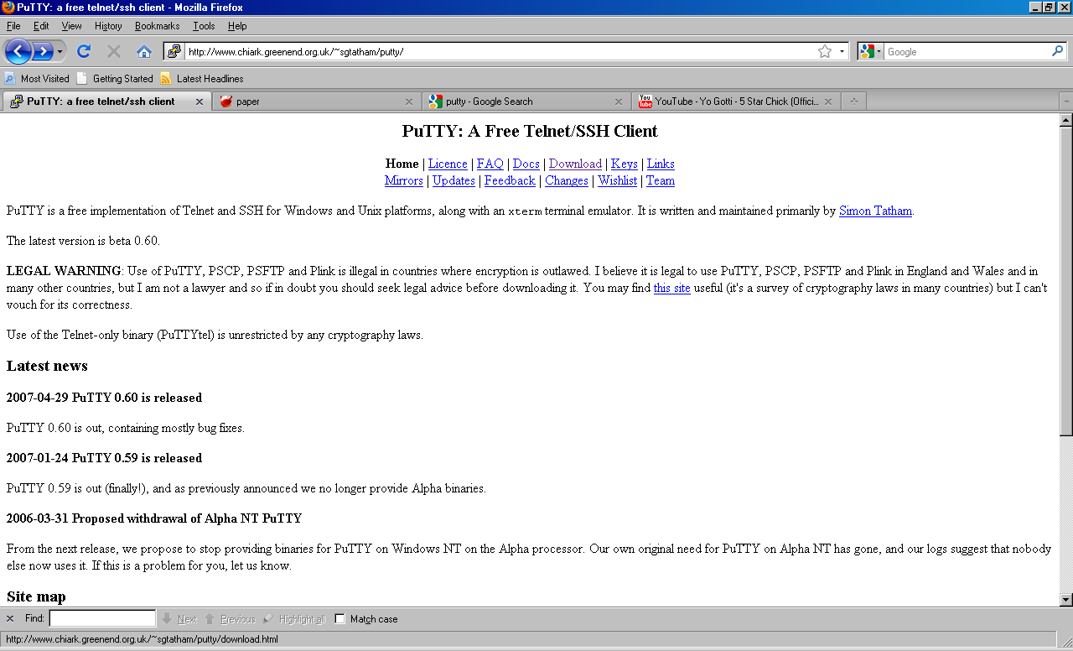

Then select the appropriate .exe file. I use the “Windows on Intel x86” section so I select “putty.exe”.
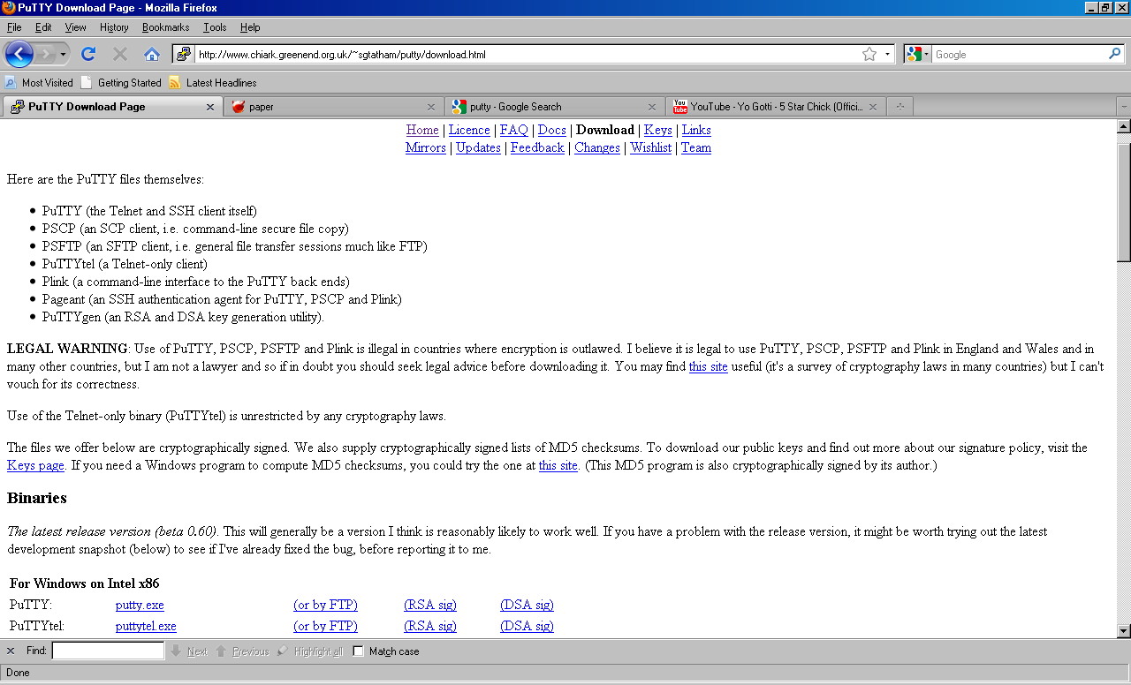

Once you have downloaded the file: Using Putty
Now you are ready to create a session and start playing with VI. You will need to know the hostname and port number at this point. If you are a UT CS/EECS student you will use the following information. The host name is “cetus” or “hydra” then the computer number you want to ssh into followed by “.eecs.utk.edu”. For example let us say I want to SSH into cetus:
Host name: cetus27.eecs.utk.edu Port: 22
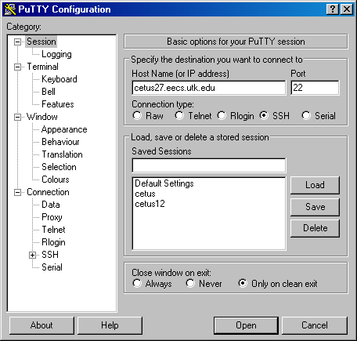

It is as simple as that. You may be asked to type in your login name and password (I have never seen this not be the case). You are now logged into a computer, now its time to play with VI. To access VI whether in a ssh terminal (such as putty) or on a Linux terminal simply type “vi” at the terminal prompt.
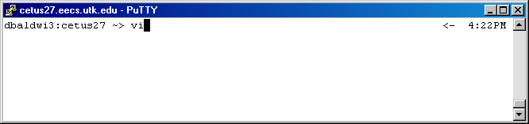

If you type the filename (along with the type of file ie. Test123.txt) vi will automatically name the file and give it the desired extension.
Naming the file before opening VI.
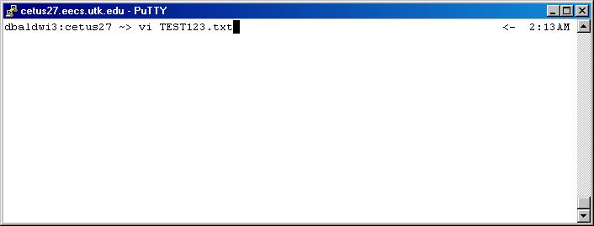
You may notice the bottom left corner message, “(filename) [New File]”. If you choose to exit the file without typing any content the file WILL NOT be created. In other words the file does not really exist yet. I will show you how to save and/or exit VI in a moment.
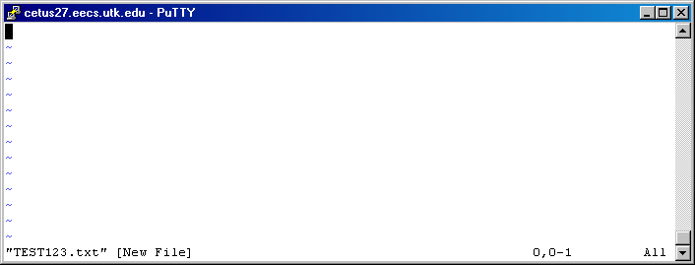

VI COMMAND/INSERT Modes
At this point it is important to point out that there are three types of modes you will use most often. The first mode we will call the VI “toggle mode”, second we will call “insert mode”, and the third mode is VI “command mode”. When in vi “toggle mode” you cannot add text to the document you working with. You can move content around in the document or navigate throughout the document. We will discuss what VI features are specifically available to you later on in this document. While in “Insert” Mode you can add and delete content from the document just as if you were editing a word document file of MS Word or Notepad. To go into VI “command mode” you simply press escape(go into toggle mode) and type “:” this will allow you to use one or multiple vi commands such as the command to save a file, delete a line, etc”. So why do I call it vi “toggle mode” because it can serve as a necessary/unnecessory method to toggle between insert mode, visual mode (which we will not discuss), and command mode. One of the most irritating things is to press colon and not actually be in “vi toggle mode”, so it’s a good practice to press “esc” twice. The first command (including for a series of commands) must be preceded with a “:”. For example ‘w’ is used to save a file and ‘q’ is used to exit vi (they must both be in lowercase so do not use caps lock). So the command for doing either one is “:q” or “:w” (quit or save, respectively). To do both you do “:wq” You would never do “:qw” because you would quit first since commands are giving in the order they entered. Remember that you must press “esc” in order to enter into “toggle mode”. To enter into “insert mode” press the “esc” once (again twice is recommended) and press “i”. It has been my experience that you do not need to actually press escape when trying to use “insert mode” but for consistency let us keep using the ‘esc’ key

Saving a file
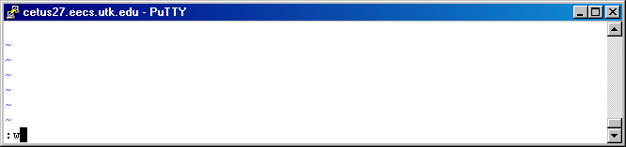
Exiting a file
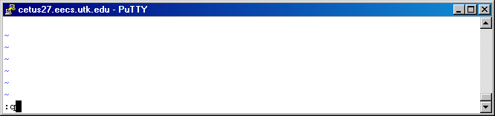

Saving and exit a file
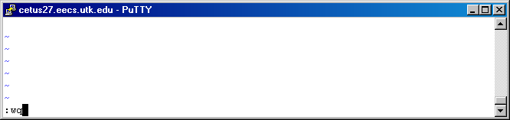

When you are in insert mode:
You can tell you are in “insert mode” when you can see the word “INSERT”
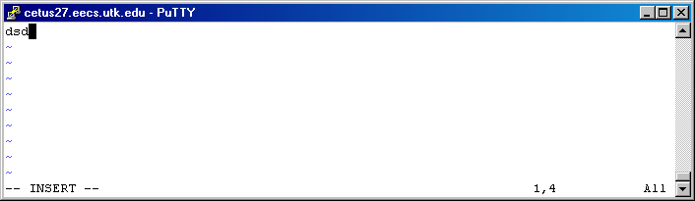

Common Unexpected Event
If you try to exit a file and there have been changes to the file that will be lost, you will see this warning message at the bottom of VI.
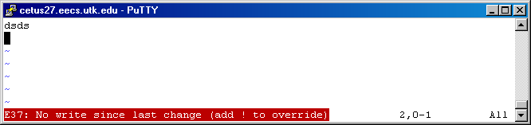
Other reasons that you will see this message include:
If you opened vi without naming a file: (goto solution A)
If you are sure you want to exit without saving first (goto solution B)
If you do not want to lose the information, save it then exit (goto solution C)
Solution A:
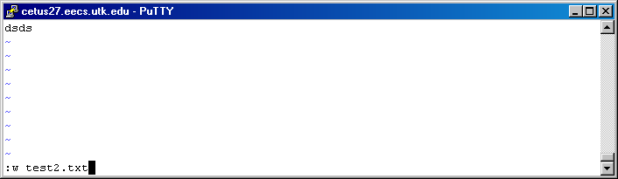
Solution B:
You can use “w!” or “q!” to override any warning messages, but for this particular case we need to use “q!”
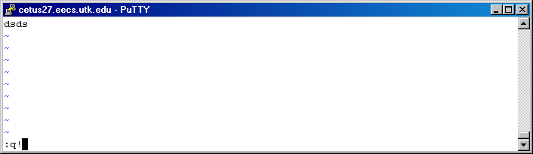

Solution C:
Let’s save this file
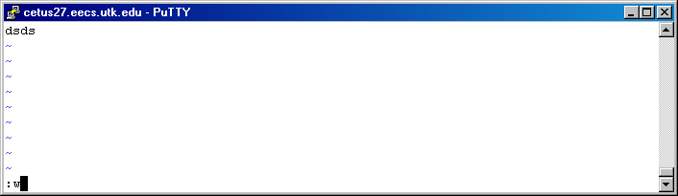

Visual Mode
There is one mode that is outside the scope of this tutorial packet, that mode is VI’s “VISUAL mode”. However, there are two things about VI’s visual mode that you must know: how to enter visual mode and exit visual mode.

How to enter Visual Mode
There is only two way to enter VISUAL mode. You must first be in toggle mode. If you press “V” this will place you in “VISUAL LINE” mode. However, if you press “v”, this will place you in “VISUAL” mode.
VISUAL LINE Mode:
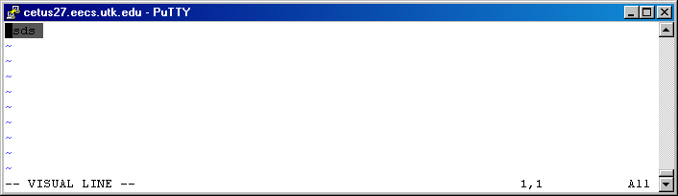
VISUAL MODE
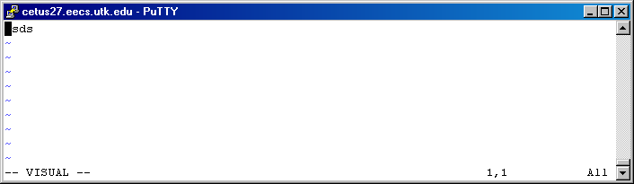
Opening VI

When you first open vi, you will see tilde “~” where there is no content for a line
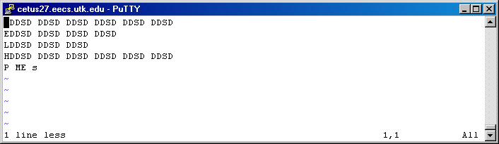
Notice the tildes in the figure above as an example.

Simple Movements in VI
UP, down, left and right
There are two methods to moving in the four general directions of vi. The first of these methods is to use the up, down, left, and right arrow keys of the keyboard. The other method is to use the h,j,k,l keys of the keyboard. The arrow keys behave in the same way as if you were editing in MS Word, Notepad, or any other similar editing application. The h,j,k, and l keys behave just as the arrow keys but we should still mention how each behaves. The ‘h’ key behaves just as the left arrow key does. The ‘j’ key behaves as the down arrow key does. The ‘k’ key behaves as the up arrow key does. The ‘l’ (lowercase L) key behaves as the right arrow could does.

Advanced Movements in VI
Word by word movement
Let us assume that you are trying to navigate to a particular word in a line. The best way to navigate to that word is to move one word forward or backwards, by pressing ‘w’ or ‘b’ respectively.
Move to the beginning, end, and middle of a file
Several keys may be used to move to the top, bottom, or middle of a vi document with a single button press. ‘H’, ‘$’, and ‘G’ allow for you to move to the top of a file. Caplock is not not needed to do this but you must be in in “vi toggle mode”. Remember to be sure you are in “vi toggle mode” just press the “esc” key twice and press “:” (hitting escape once should put you in “Vi toggle mode”). You may also use the common sense approach and type ‘M’ or ‘m’ will put you at the middle of a file instantaneously. Also to get to the bottom of the file you have two options. Option 1: use the ‘l’ command
Variable movement
In this section you learn how to move a certain number of char or lines in any direction. Let suppose you want to move 10 lines down a file. All you have to do is get into “command mode” and type the number lines you want to move and then add the “+” sign to the end (ie esc, :10+). Now suppose we want to move 25 lines up a file. Get back into “command mode” and type the number lines you want to move up a file then put the “-“ sign (ie esc, :25-). Lastly to move a certain number of char left/right you must use the ‘h’ or ‘n’ key respectively. To move left, say 10 characters, you must type (10h) and to move right 10 characters (10 n).
To ever cancel a command (no matter the mode you are in) HIT THE ESC key
To move down/up a file
There are several ways to move down/up a file using the ctrl key. The first group of movements is to move an entire page (usually 40 lines). To do any of these you must be in “toggle mode”. To move down a file 1 page, press “ctrl-f” or “ctrl-F”. To move up a file one page at a time you can use either “ctrl-b” or “ctrl-B”. What if you just want to move half way up a page? Well you can do that too. Once again you must be in “toggle mode”. To move halfway up a page you must press “ctrl-u” and to move half way down a page use “ctrl-d”. Keep in mind that using “ctrl-u” in toggle mode is the same as using ‘M’ in command mode.

Common Unexpected Event:
Now suppose you lose an internet connection while remotely logged into a computer. Odds are when you reopen the file that you were editing, you will see this screen:
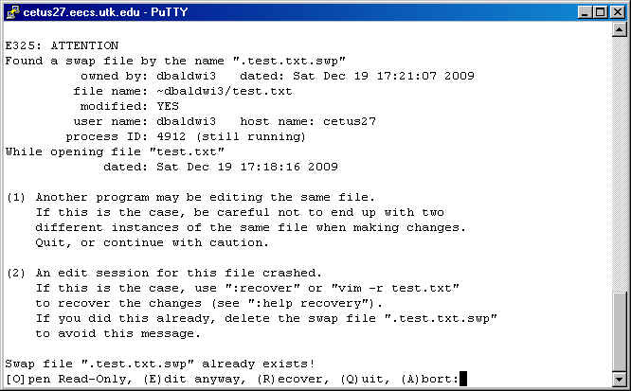
This happens because a copy of the file that you are editing is continuously being updated. This copy exist for occasion when VI is terminated unexpectedly. Next time you try and reopen the file you will see the above screen. At this point you must make an “life-death” decision, because the goal is to recover the most recent file possible:
Edit Anyway:
This option will allow you to edit the swap-file so that you can work with it. At this point, you should exam the file. If the file seems to be very recent (look for the last thing changed) then go ahead and save the file “w!” .
Quit/Abort:
Choose either of these options if you want to return back to the command prompt and not access VI.
Open Read-Only:
This opens a version of the “non-swapped” (manual saved) filed that you cannot edit you can only
Recover:
If you choose this option then the non-swap file will be recovered. If you use “w!” when you choose to save the recovered file, then there will be no way to access the “swapped” filed. Why would this be a problem? Well suppose the swap file is older (not as recent) than the last time you saved the file you were working with. Then the swap file would not be the file you want to use “w!” on.
Delete (optional):
Sometimes you will see another option that allows you to delete the swapped file. You should only use this option after viewing the “swapped file” and realizing that you do not what it. This requires that you follow a particular process. First you must view the file and then use “q!” without saving the file. Then reopen the file and choose the delete file.

Advanced VI features

Deletion Functions
Delete content from the location cursor to a certain point in the file
There atleast a dozen delete methods in VI. In this tutorial they are group by the amount of content that each command can delete. First let us start with the command for deleting the next word. Keep in mind all of these delete commands start where the cursor’s current position is and does not stop deleting until it has completed its functionality. All of these commands must be down in the “toggle mode”. The first command is “dw”. “dw” removes the content that starts at the cursor until it reaches the a space in a file. There is not a command for deleting the previous word, the only chose for that is backspacing while in “insert mode”, just as you would in any text editor.
Suppose you want to delete the content of a line. In that case you can use the “d$” while in toggle mode. Place the cursor where you want to start the deletion process and “d$” will delete all the content that follows it until it reaches the end of that line.
There are two ways to delete an entire line. Both methods require for you to be in “toggle mode”. The first method also requires that you be at the line that you want delete. Using the first method, simply press “dd” and it will delete the current line of where the cursor is located. The other method requires that you know the line that you want to delete and press (line number without parenthesis) and “Gdd” ie (5Gdd). (‘G’ has to be in caps)
Now two other more powerful deletion techniques (more powerful because they delete more content) are “dh” and “DL”. Once again toggle mode is needed. “dh” deletes all the content following a cursor until it reaches the end of the page currently being viewed.
If you want to delete all the content of a page you can use several approaches. The first of which is common sense if you understand something aboiut the use of “dd”. When every you use “dd” the vi editor is expect you to enter a page number between the two “d’s”. The default for this is 1 line, thus “dd” does not need to have “1” between the two “d’s”. However, should you want to delete a series of 10 lines you can type “d10d”. This will start with the line where the cursor is at a delete that line, along with 9 lines below the cursor’s current location.

Copy (aka Yanking) and Pasting Feature
VI supports quite a few methods for copying content of a file. Two methods are to copy a single line and the other to copy multiple lines.
Just as with deletion methods, the copying methods all start at the position of the cursor.

Single Line copy and paste
Suppose you want to copy a single line. Then you can do so by simply pressing “y”(lowercase) twice while in toggle mode. You will see the “1 line yanked” in the lower left side of the VI terminal.
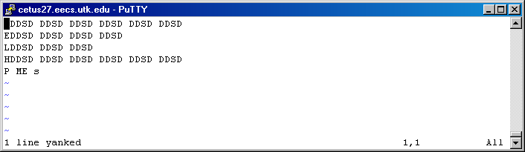
Now to paste what you have copied, simply move to the line of the file where you want to copy the content to. Then press “p”(lowercase). This will paste the new material and the message “1 more line” will appear in the bottom left
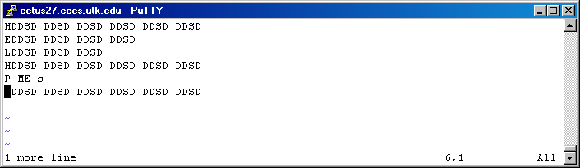
If you want that line you have copied to be pasted multiple times, then repeatedly press “p” until the number of pasted lines have been made.

Multiple line copy and paste
Suppose you want to copy more than just one line. Then move the cursor to the line you want the copying to start at. Then press “y” then the number of subsequent lines to copy and “y” again. A message indicating the number of lines you have requested to be copied is placed in the bottom left.
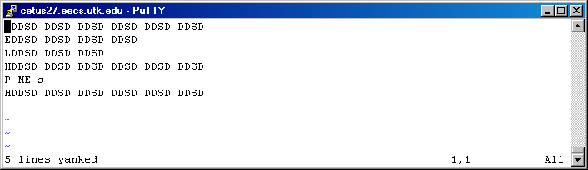

What is nice is that the delete functionality can all be used in conjunction with the paste. In such a situation, deleting a line/multiple lines and then pasting those lines in a new location behaves as a cut and paste. Simply put, the objective is to remove content from one location of the file. Then place that removed content into a different location of the file.

ADVANCED COPY AND PASTE FEATURES
Suppose you want control the direction in which the copying and deleting is done. That is simple to do also.

Directional Control over Copying
To control the direction of the copying, simply type “y” then the number of lines you want to copy while in toggle mode. Then press the up or down arrow keys to copy in that direction. You may also use the “j” or “k” keys as a substitute for the up and down arrow keys. Suppose you want to copy a certain number of characters of a particular line, that can be done the same way as with copying lines. Simple press “y” then the number of characters you want to copy, and finally the left/right arrow keys. There are a few things that are important to mention when you copying characters of a line. First off, there wont be a message to appear to let you know you have copied the characters. You have to have “faith” that when you press the “p” what you thought was copied was actually copied. Secondly, when you hit “p”, the cursor will sit on the last character. So for example, in this particular case I requested that 5 characters be copied. Then I passed what would seem to be only 4 characters.
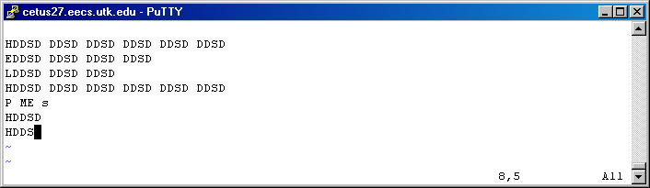

However, by moving the cursor to the cursor, I soon realize that the fifth character was sitting underneath the cursor.
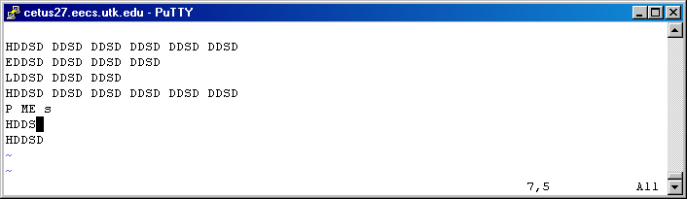

I know you probably think you have more deletion commands than you can shake a stick at. Well here are a few more. You can delete in any direction just as with copying command mention here recently. The only difference is that you must press “d” instead of “y”.

The purpose of mentioning these advanced delete and copy techiniques is for you to remember to use them in conjunction with the pasting technique to create useful methods to “copy and paste” or “cut and paste” whenver convenient. However, if you every do something you do not like there is one even more powerful tool in VI: the undo option.

The UNDO FEATURE
From the moment you open a vi file and start typing you are able to undo everything you have done. This is an extremely helpful when you have done something you wish you had not done. Now assume you did something and you want to undo it, simply enter “toggle mode” and press “u” (lowercase). Here is an example
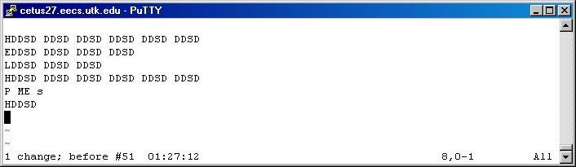
At the bottom left you will see the number of lines that were affected and the time the file was last at that state.

Temporarily Exiting VI
You may temporarily exit VI to go to the command-line. This is extremely helpful if you want to use a simple Linux commands such ls, open a browser, etc. To do this simply enter “command mode” (Remember go to “toggle mode” then press “:”). Then press “!” and enter the desired command. Here is an example of me utilizing “!” to see the files in my current directory.
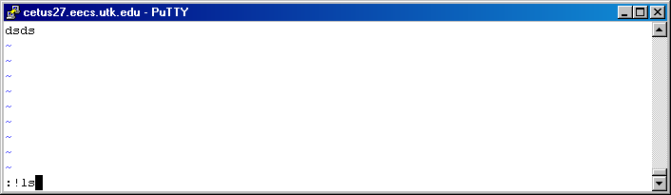
When I pressed the enter key, the commands I requested to be executed at the terminal command line were used (in this case “ls”).
If you do not know what ls does, it list all the folders and files in the directory that “ls” is used in
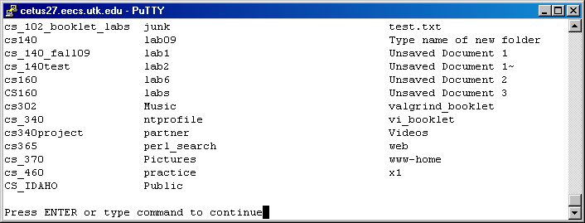
By pressing the enter key, I am returned to VI.

Indenting Your Code and Checking

Vi supports a feature to automatically indent content of code. Lets call this feature “auto-indent”. What auto indent does, by default, is set the space for the tab key, and encapsulated code to four spaces. Suppose you want to change this setting, so that it allows for you to indent 6 characters in. Then you first would need to be in command mode and type “:set sw=6”.

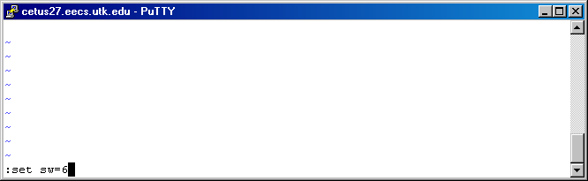

Think of “sw” as short for “shift-width”. Now here is the results of setting the shirt (tab)-width to 6

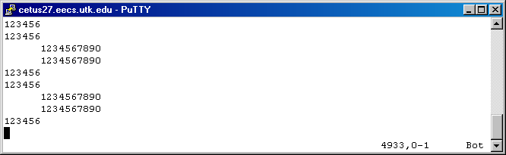

One nice thing about auto-indentation is the feature that will run through the file automatically indent things that are “believed by vi” to be encapsulated

Here is a perfect example of code that has been poorly indented.

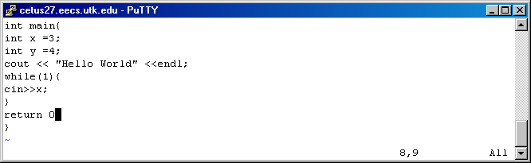

I can automatically have vi indent all the lines appropriated by first being in “toggle mode”. Then move the cursor to the top of the file and entering the number of lines in the file and the “=” key twice. When you code get ridiculously huge, it might be a good idea type “10000” (with 5 zeros) for the number of lines. That way you don’t have to know the number of lines in the file, you will be sure to indent all the lines. This is the result of tying “100= =” while in toggle mode

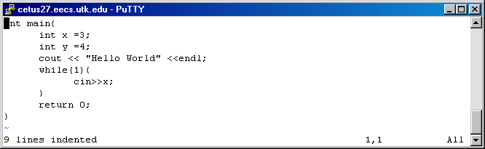

Vi tells you the number of lines that were indented as a message in the bottom left corner of the window.

Closing/Opening brackets or parenthesis search

Vi has two features for checking for opening/closing brackets. These brackets allow for you to check if your code is missing parenthesis or brackets. The first feature is automatically utilized anytime you move your mouse over a open or closing bracket or parenthesis. This feature will hightlight the “partner” bracket/parenthesis to reduce the difficulty of finding the tag. In the below figure I have moved the cursor over the bracket on the life “int main{“ to find the closing bracket of main()

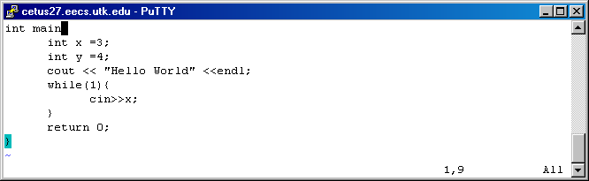
The second feature for finding closing and opening brackets/parenthesis is useful when the file spans more than one screen. This feature requires that you be in “toggle mode”. Move the mouse over the first open/closing bracket/parenthesis. Then press the ‘%’. This will search the file for the “partner” key and take the cursor to that opposing key. In the below example I moved the cursor over the { on the first line. Then I pressed ‘%’. This is the result
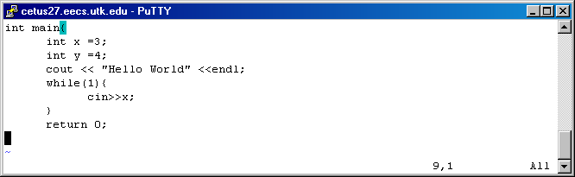
Notice that the cursor has moved to the bottom of the closing bracket of the main().

Now suppose you want to shift a line to the left/right by one simple way to do this is to utilize the “<<” or “>>” inputs. These require that you be in toggle mode.

In this particular case I moved the “return 0;” statement to the right 1 shift-width by placing the cursor on that line while in toggle mode, and typing “>>” (this required that I press the shift key). The message in the bottom left corner lets me know that 1 line was shifted to the right 1 shift-width.

1 LINE IS Right Shifted 1 shift-width

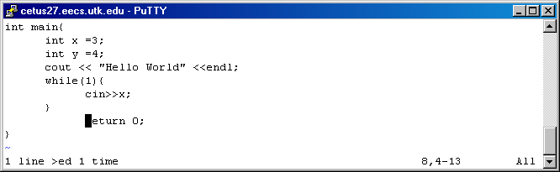

1 line is Left shifted 1 shift-width

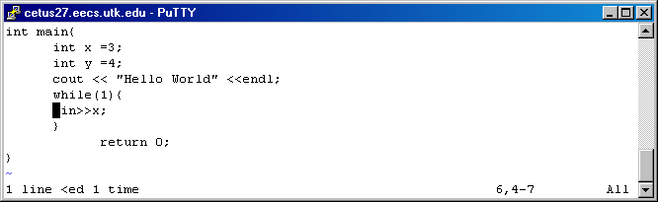

Advanced SHIFT-WIDTH Features

Suppose you want to shift more than one line left/right. Well that is easy to do also. First move the cursor to where you want begin the indentation. Make sure you are in “toggle mode” then press the > or < sign for right/left indentation. Then enter the number of line you want to indent. Then press the corresponding > or < sign again. This will indent the subsequent line appropriately. Here is an example of a snippet of code prior to indentation:

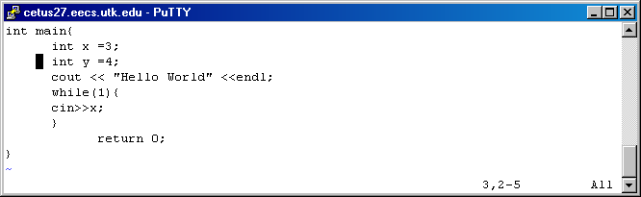

I want to indent to the right indent 4 lines 1 shift-width: so while in toggle mode I type “>4>” and this was the result

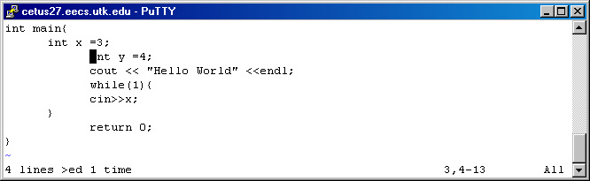

The message in the bottom left lets me know that 4 lines were indented not just 1 (besides the fact that it was clearly obvious).

The same method works for left shifting. As you can see indentation can be a very helpful and easy to use tool in VI.

SEARCHING METHODS OF VI EDITOR

VI supports two methods of searching through a file: string and character. The first method requires that you search the file for a particular word, phrase, or statement.

The other search method, character search, processes a line/lines for a particular character. Let’s first look at the string search method.

For a string search you must use either the “/” or “?”key. If you use the “/” then you are going to search for the desired string on all lines below the cursor. The “?” allows you to search for the desired string on all lines above the cursor.

In the bottom left is the search expression that I used. All search expressions do not have to be in the command mode. In fact, command mode does not lend itself to be as reliable as just tying the search expression in toggle mode. But First I would like to show you that it does actually work in command mode: The cursor was origin on the first line, and immediately jumped to the beginning of “while” on line 5

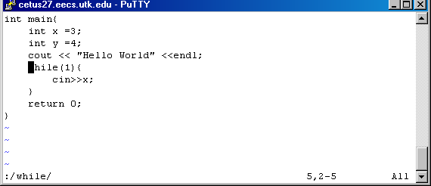

The bottom left show s what I typed to search above line 5 for the statement “int y”, the first (and in the case the only) occurance is at line 3

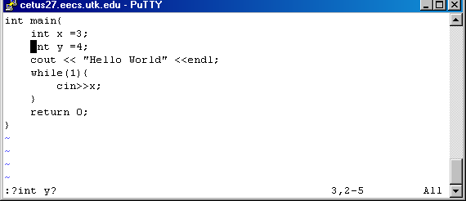

To repeat the next string expression in a search you can use the “n” or “N” key. The “n” key will search in the original direction. While the “N” key will search in the opposite direction.

Special Characters

There are some characters that have special meanings in VI, and therefore needed to be preceeded by a “\” just before the special character. To the best of my knownledge there are only five: “^”, “$”, “.”, “[ ]“, “< >”.

If you have ever used regular expressions of Javascript or Perl then you will most likely have no problem using VI search tool because they are very similar in usuage. For example, all the special characters of vi are also special characters in Perl and Javascript. So what does VI’s special characters do?

^ (carot) is placed at the beginning of a search expression

Notice the location of the cursor, the expression entered in fig.2 searches above the cursor for the first occurrence of a line that begins with “back” since I placed the carot sign in the expression. Had I not placed the carot sign in it, vi would search for all occurrences of “back” no matter where it was above the cursor.

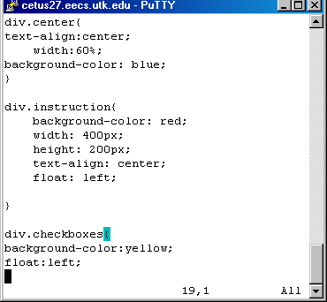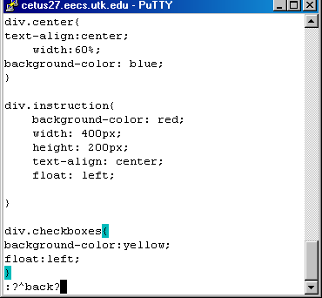

VI identifies this as the first occurrence of the string “back”, as expected. However, notice carefully what it determines as the next occurrence of the string “back”. In fig.2 it recognizes the next occurrence to be on line 4, not line8 “background-color: red” why? Because that line begins with a space (actually 4-5 spaces) not “back”. Thus VI skipped it and moved on to the next occurrence.

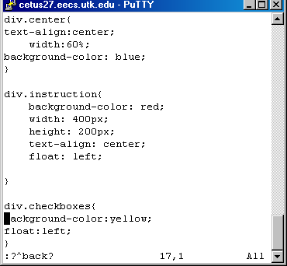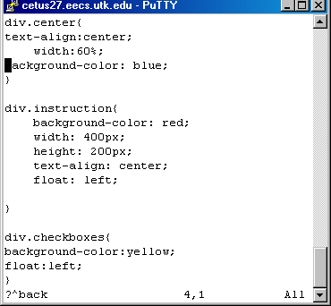

$ (dollar sign) is placed at the end of the search expression.

In this particular example, and other examples I will not use the command mode for search expressions of string type. Notice where I placed the cursor for this example. In fig2 you see the search expression I gave to toggle mode, and you see where the cursor jumped to. It is only concerned with where red is

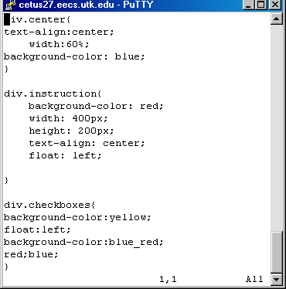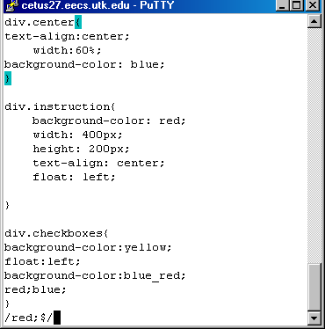

Notice where vi moved the cursor

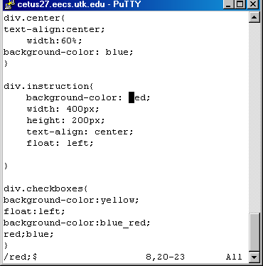
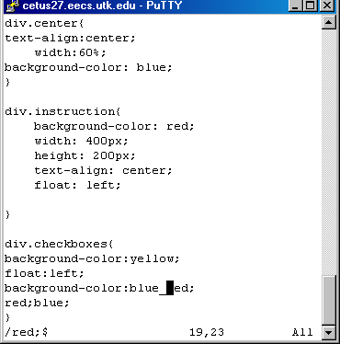

The message at the bottom of figure 3 lets me know that vi reset itself to the beginning of the file (line1) and started searching from that location. What Is important to note is that it skipped the “red;” on the second to last line. That is because that particular “red;” is not at the end of the file. Therefore VI skips it.

“Search hit bottom, continuing at top” is pretty explainatory.

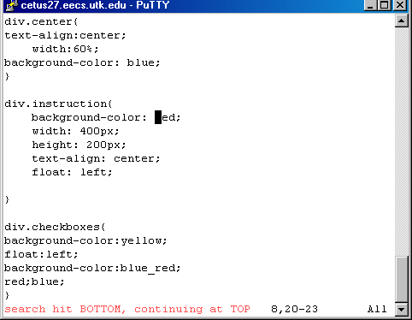

. (period) will match a single character of a string except the “\n”

You use this the same way you use3 the asterisk, therefore I did not create a screenshots for these

* (asterisk) will match 0 or more occurrences of the previous string.

The asterisk is helpful when you have a set of characters that you want to consider as optional requirements in your search. For example, in this particular search I want to look for all strings that contain “div.c” but I want to consider the “h” as a optional and the “e” to be required next. Notice I did not put the ending “?” because just like the command mode is optional, so is the the ending “?”

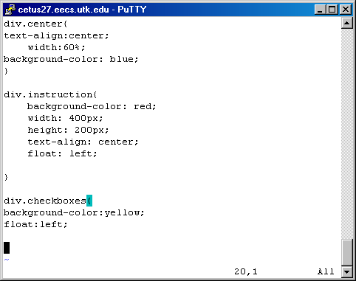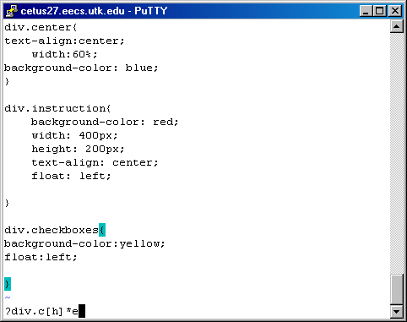

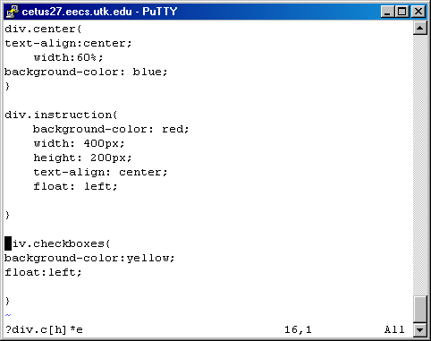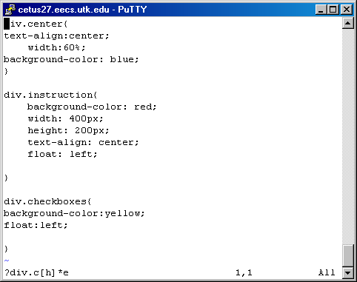

[ ] (open bracket and close bracket) are used to match/not match a set or strings. I will go in detail about how to use it because it has some pretty nice features

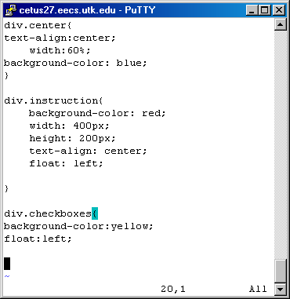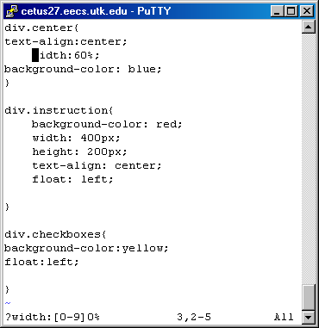

Here are some other examples of string sets than can go into the [ ] that you can try:

[a-zA-Z] – searches for all letters of the alphabet, but not numbers

[abc] – searches for either “a”, “b”, or “c” to one of the letters (ex. Try “?f[la][to]a” as a search expression for the above file)

[^a-zA-z0-9] – the carot sign causes vi to not search alphanumeric characters (letters or numbers) (ex. Try ?f[^a-zA-Z0-9]

< > (less than) whatever string is inside the <> will searched for at the end of a word. I will go in detail about it shortly to show how powerful it is

Character Search

The character search is uses the f and the F are used search for the character the same line as the cursor is on. The f key searches right and the F key searches left. The most annoying thing about the “f” and “F” keys is that they move the cursor over the character so you cant see it. (demonstrate the character search with “f” or “F”) Also when doing a character search you do not get to see what you searched for in the bottom left. The convenient solution is to use “t” or “T” they behave as “f” and “F” would respectively, expect they move cursor to the character before or after the found character. This way you actually see the character you were searching for.

For example notice this

The cursor is at line 3 of the document. Now I will type “f s” but nothing will show up in the bottom left. As soon as I type “f s” (figure 2) the cursor is moved over the character.

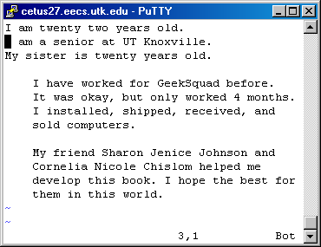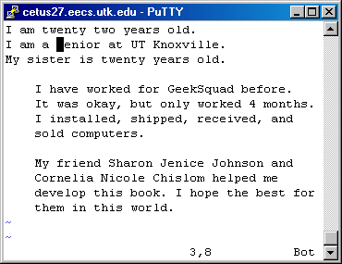

In this particular example I use the t key instead of the f key. That way the cursor will not appear over the letter. I have changed the document slightly (fig 1). I want you to understand a few things. The character search is case sensitive, “c” is different than “C”. Next the only thing that determines a “new line” in VI is the Enter key. Therefore, though it would seem that the second sentence of line three “I have worked…” ends on the next line (line 4) it really is still on line three. When I typed “t G” the cursor did not move over the “G” in Geeksquad but stopped before it.

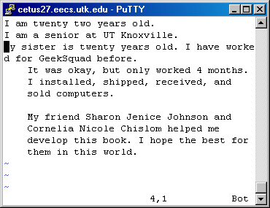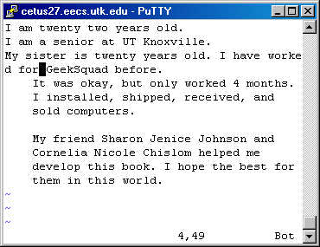

For the character search you can must use the “,” or “;” to search for the next or previous character. The “,” (comma) will character search in the reserve direction of the original search and the “;” will continue the search in the original direction.

Settings in VI:

VI has dozens of settings that are available to you. You already know about the shiftwidth (sw) command. There are two ways to access these settings: “set all” or “set”. Both commands need to be given while in command mode. Well other commands that I find useful are wrapmargin (wm), wrapscan (ws), showmode (smd), number (nu). Here is an example of me utilizing the “set all” command.

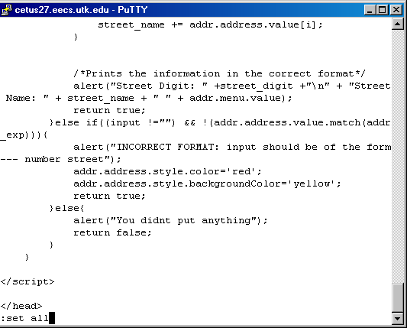

This is an example of the overwhelming number of settings available in the VI editor. There are over three pages of these settings available. This is just page one.

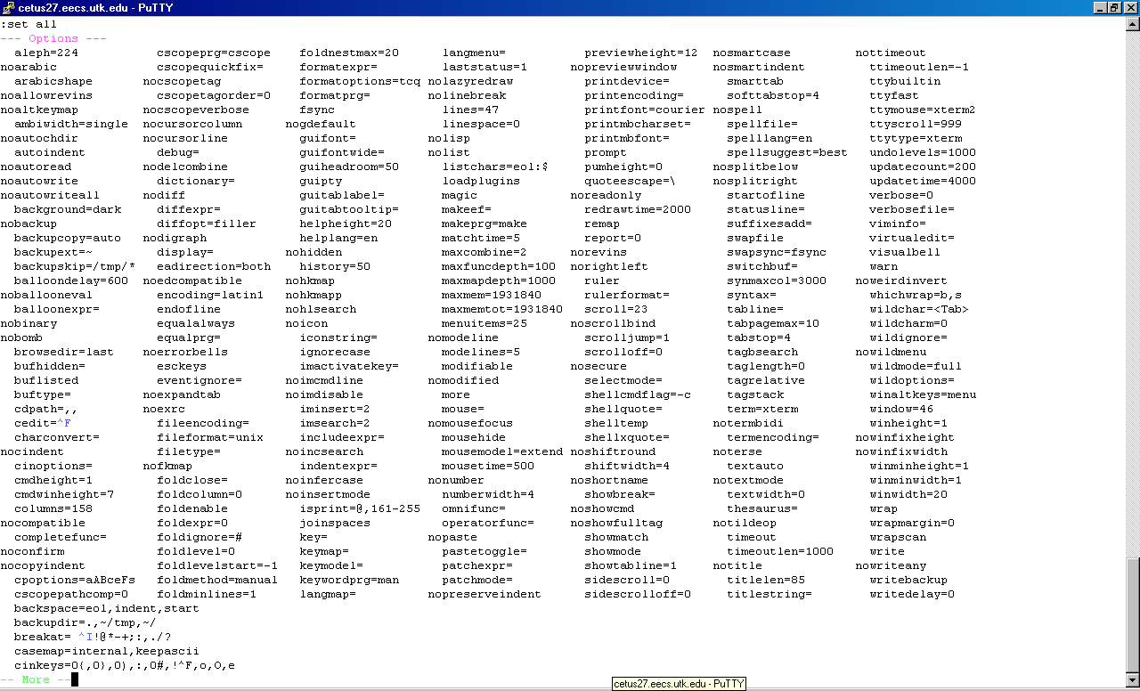

Possibly in the beta version of this tutorial packet I will provide more examples. But I feel the above mentions commands are the ones that are most relevant. Also these are the commands that I have used very frequently while using vi.

The showmode (smd) command lets you know what mode you are working with

To set smd to on (aka true) you must type the follow set command in the command mode. Even though I am in insert mode (fig. 2) it does not show because I have used the command “set nosmd” which turns showmode off.

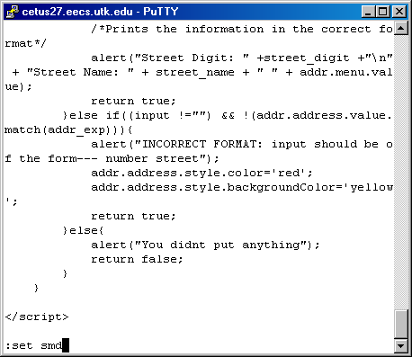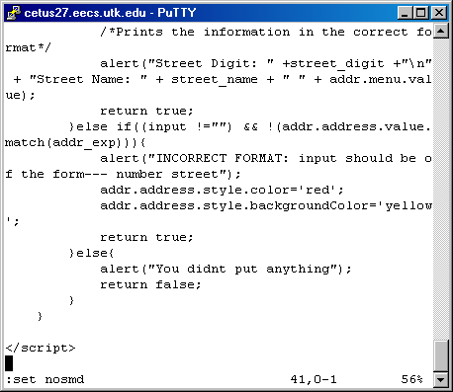

(demonstrate this mode with and without smd)

The wrapscan (ws) command lets you determine whether or not a expression search should stop when it reaches the top or bottom of the file or continue searching until it has searched the entire document

(give 3 examples, one to show what it is meant by wrapscan, one to show wrap scan typed in, one to show wrapscan complete)

The number(nu) command allows you to determine whether or not number should show up to the left side of the screen to let you know the linenumbers.

(demonstrate this while entering the command, then demonstrate after)

The showmode (smd) this command is what allows you to know what mode you are in, if you think you are in VI’s insert mode and it doesn’t show the mode in the bottom left then it is time to change this setting (unless of course you didn’t want it show).

(Demonstrate while entering set command, and the results)

The autoindent(ai) command is what cause the next line to have the same indentation as the line before it.

In fig 1 you see the command that I gave to turn autoindentation off. Notice carefully the location of the cursor (nosmd is also set thus insert mode is not visible). In fig. 2 you see that the cursor starts at the beginning of the line after I hit the enter key. This would not be the case had autoindent been set (fig 3)

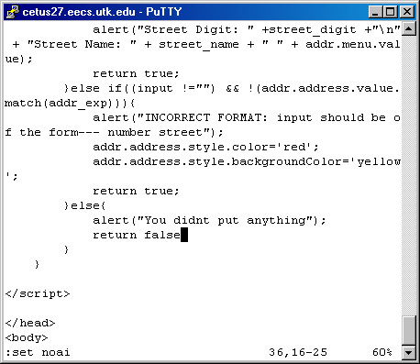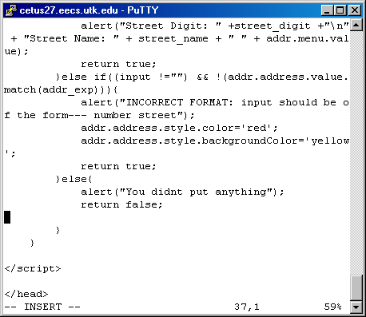

As you can tell the indentation starts where the previous line left off. This is extremely helpful when programming. (fig. 4)

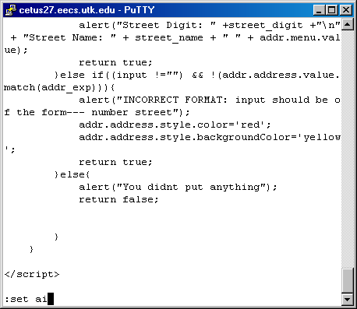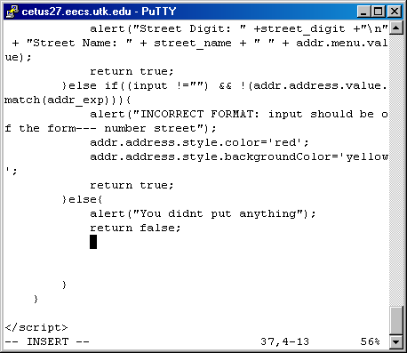

To make the number of lines to show up on the left side of VI simply type the below command. The VI program will change to fig. 2.

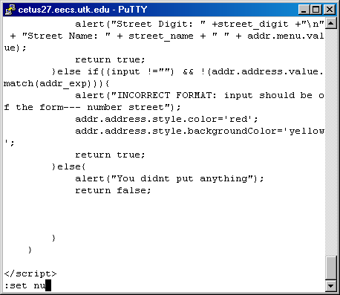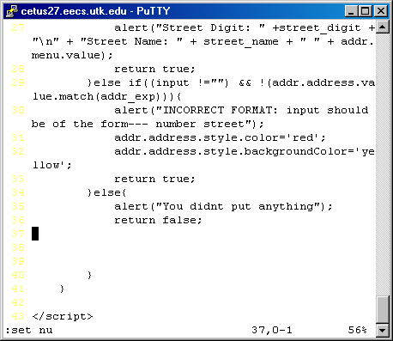

Notice below where I have placed the cursor. This time I will show you what happens when the wrapscan is off. To turn wrapscan off, simply enter command mode and type “set nows” (FIG 2). Fig. 3 shows you what happens when wrapscan is off and you reach the bottom or top of the screen.

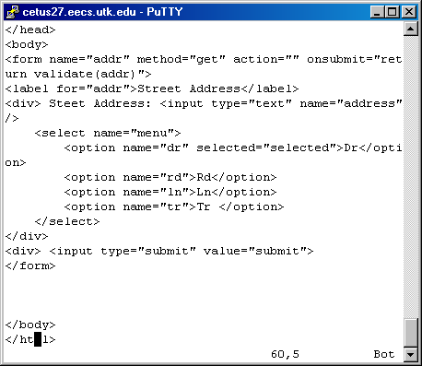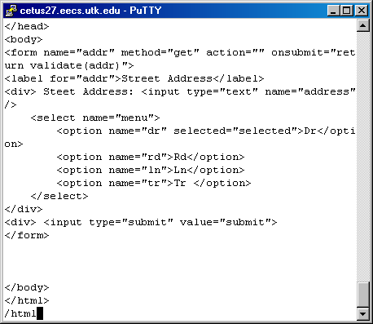

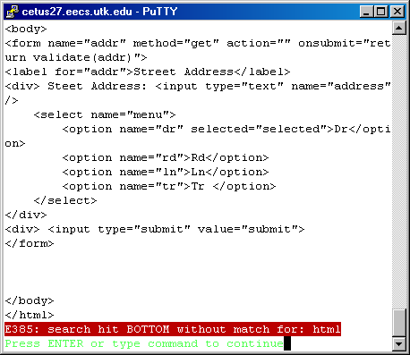

The message is pretty much self explanatory. Regardless of whether or not a match is found. This message will still appear, because it only appears if you try another search and it does not find anything .

Replacing Text
This mode will probably be discussed in the beta version.
This concludes the alpha version of the VI MANUAL. I feel that this tutorial packet will cover the basics of using VI. But more than that, it will provide a experienced user’s perspective on the use of the Visual Editor and its many functionalities. The greatest challenge with using this particular editor is knowing how to address certain issues and understand the different warnings that may occur while using VI. Once again, a special thanks to Sharon Jenice Johnson and Cornelia Nicole Chislom for their grammatical and editorial experience in the development of this packet. I could not have completed this packet without there help.

